NAME: ____________________________________

Exercise 1 (a-e) set-up
Use Google Scholar to find the source of a quotation. Get Ready:
- Go to Google Scholar by entering the URL http://scholar.google.com in your browser's address box, or by holding down the Ctl key while clicking on the link (Windows), or by clicking the link (Mac).

- Click on the “Menu” icon and then on the “Cogwheel” icon to check the Google Scholar settings.
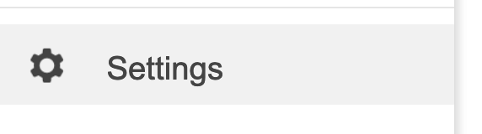
- When you reach the “Settings” page, click on “Library links”
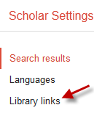
- Is University of Nebraska Medical Center – UNMC eText listed and checked? If not, search for – UNMC – and then check and save the “University of Nebraska Medical Center – UNMC eText” option that appears.
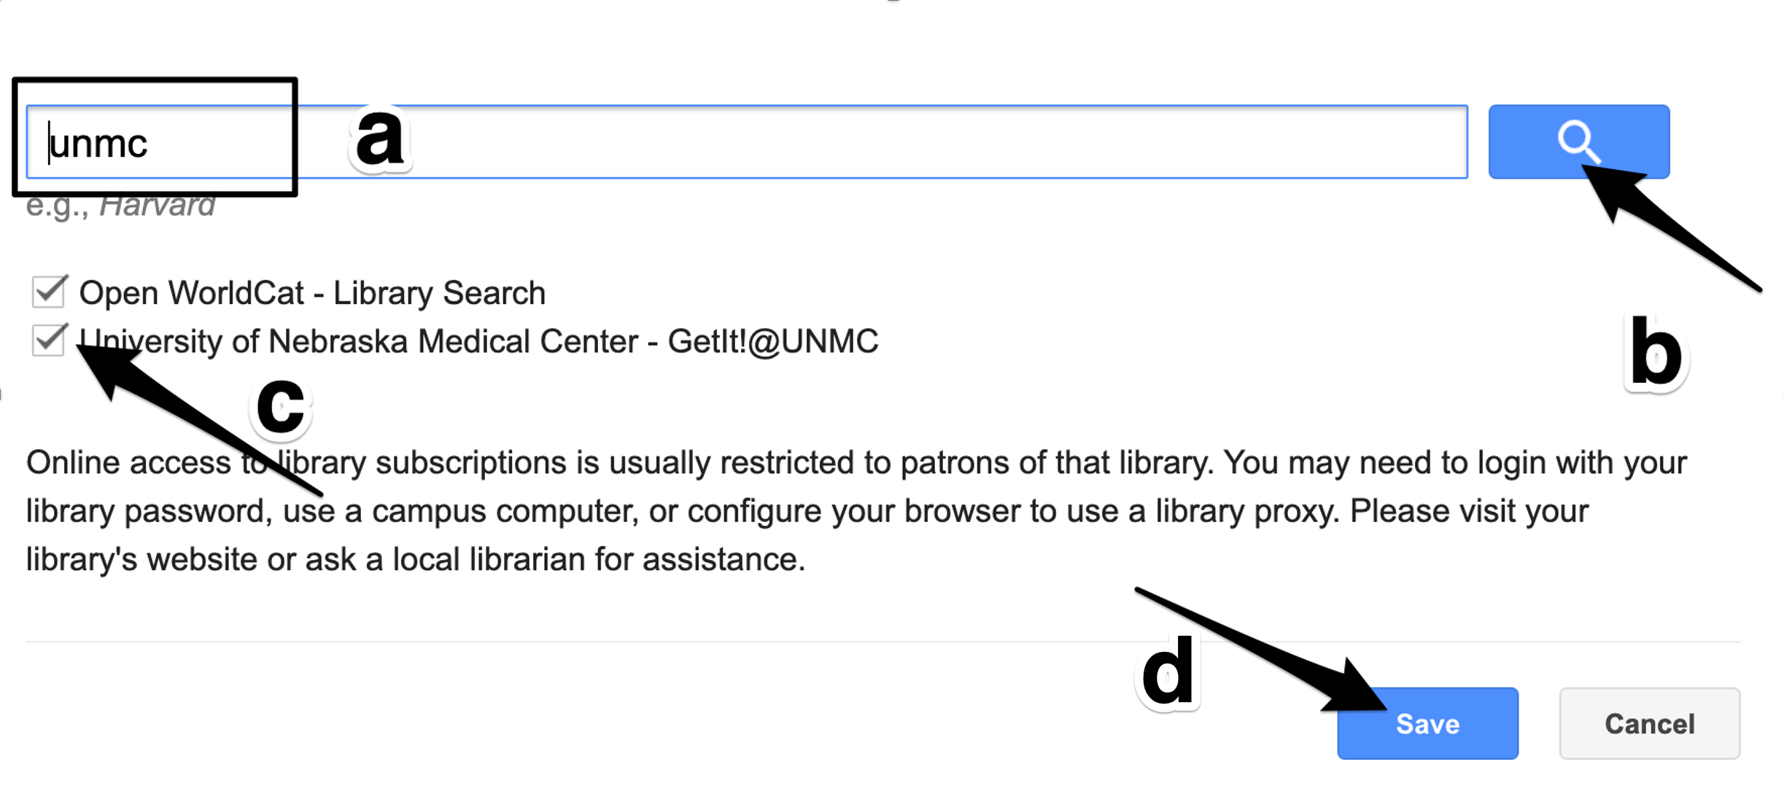
Problem:
You and another student have just completed a research elective. You completed a discharge counseling study in Nebraska Medicine’s pharmacy and are presenting a poster describing your work at a national meeting. The other student has revised the poster’s text and has inserted the following sentence in the poster’s “background” section.

The pillbox fill test "is a practical way to measure executive function in medication intake behavior."

Unfortunately, your coauthor failed to include the citation information for the article containing the quote and can no longer remember where he got the quotation.

- Search Google Scholar (scholar.google.com) to find the article that contains the quoted phrase. Click the "GetIt!@UNMC" link in Google Scholar.
- In the new window that opens after you click the "GetIt!@UNMC" link, find the "Full text availability - click link below to log in" area of the page and click one of the sources for the full-text content licensed by the library.
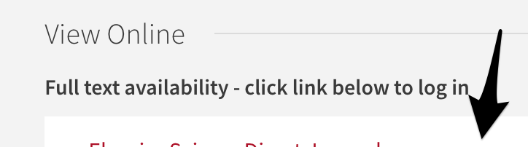
- If the article's webpage doesn't appear but, rather, a general journal webpage or search page appears, go back to one of the previous tabs, and copy the article title. Return to the journal/search page and search for the article title.
- One you reach a webpage containing the article title, find and click the "PDF" button/link on the page that appears.
- Use the full-text article to answer questions a - e:

- What is the name of the journal that published the article? (I'm asking for the name of the journal, not the title of the article.) To find a journal's title when looking at an article pdf, look at the top or the bottom of the page. The journal title is often in one of these locations along with the volume and issue number.

- In what year was the article containing the quote published?

- What is the number of the volume that contained the article?

- What is the article’s first page number?

- What page contains the quoted phrase? (hint: You can use the find feature to find one of the words.)

Exercise 2 (a-c) navigation
Use the CDC’s Yellow Book to find Malaria prophylaxis information for a patient who plans to travel.
Get Ready:
- Go to the CDC website by entering the URL http://www.cdc.gov, or by holding down the Ctl key while on the link (Windows), or by clicking the link (Mac).
- Click on the "Traveler's Health" button.
- The CDC changes their website frequently. In the future, you may need to look for a "Yellow Book" link and then look through the "Table of Contents" to find the "Yellow Fever vaccine & Malaria Prophylaxis Information, by country" link. At the moment, the "Destinations" area is front and center on the Traveler's Health page. Find the country of interest (in this case, Togo).

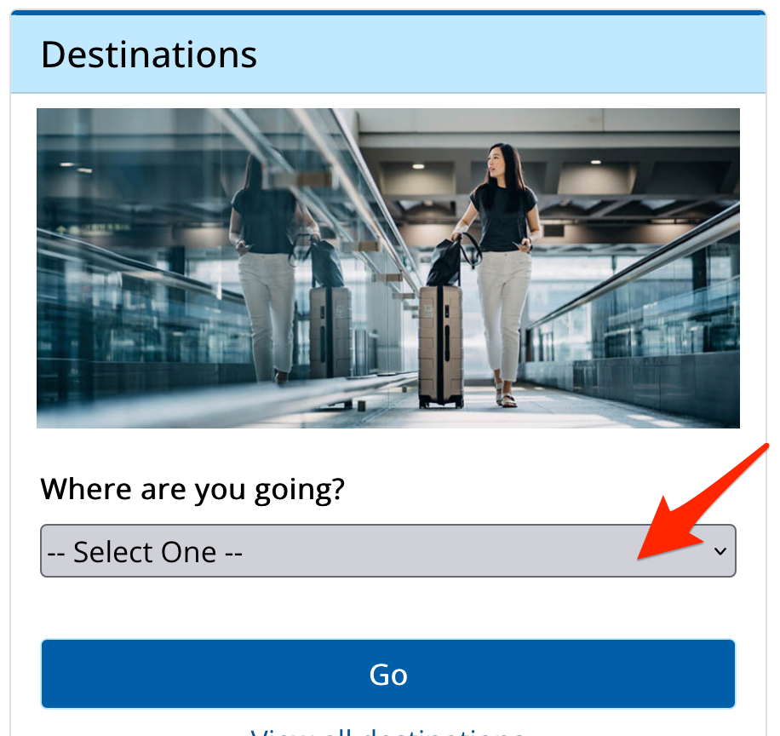

- Click on the "Malaria Information for country name (e.g. Togo)" link.

The Problem:
A physician calls because he is seeing a patient who plans to visit friends in Togo. The physician needs to know whether anti-malarial prophylaxis should be recommended, and, if so, what drugs should be prescribed.
- Is malaria prophylaxis recommended for those taking the described trip?

- If so, what drugs should be recommended?

Exercise 3 (a-d) navigation
Use the FDA’s orange book to decide whether a patient can safely switch to a generic drug.
Get Ready:
- Either:
- use this link https://www.accessdata.fda.gov/scripts/cder/ob/index.cfm
or
- search Google for – "orange book" FDA .
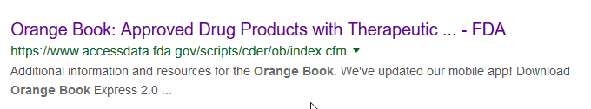
When you reach the Orange Book's homepage, click the large "Search the Orange Book Database" button.

- Use the "Search by Proprietary Name, Active Ingredient, or Application Number" search box to search for the drug's generic name..
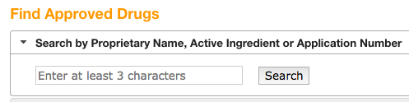

The problem:
You have a patient who has been taking topiramate 25 mg, oral extended release capsules from Glenmark Pharmaceuticals (application # A210278) for epilepsy. There's a shortage of this medication. You would like to switch him to topiramate 25 mg, oral extended release capules from Zydus Pharmaceuticals (application # A207382)

Search the Orange Book for --

topiramate

- What is the TE code for topiramate 25 mg, oral extended release capsules from Glenmark Pharmaceuticals?

- What is the TE code for topiramate 25 mg, oral extended release capsules from Zydus Pharmaceuticals?

- Are the 25 mg extended release capsules from Glenmark and Zydus considered therapeutically equivalent?

The dosage, delivery method and TE (therapeutic equivalence codes) for two preparations must be identical before they can be considered therapeutically equivalent.

Exercise 4.
You're working in a drug information center. A colleague had heard about a study of sumatriptan in post-traumatic headache that had been completed sometime during the past 5 years. She asks if you can locate the names and addresses of the study investigators
- Go to ClinicalTrials.gov by entering the URL clinicaltrials.gov in your browser's address box, or by holding down the Ctl key while clicking on the link (Windows), or by clicking the link (Mac).
- Make entries in the "Search" boxes as shown below and hit the "Search" button:

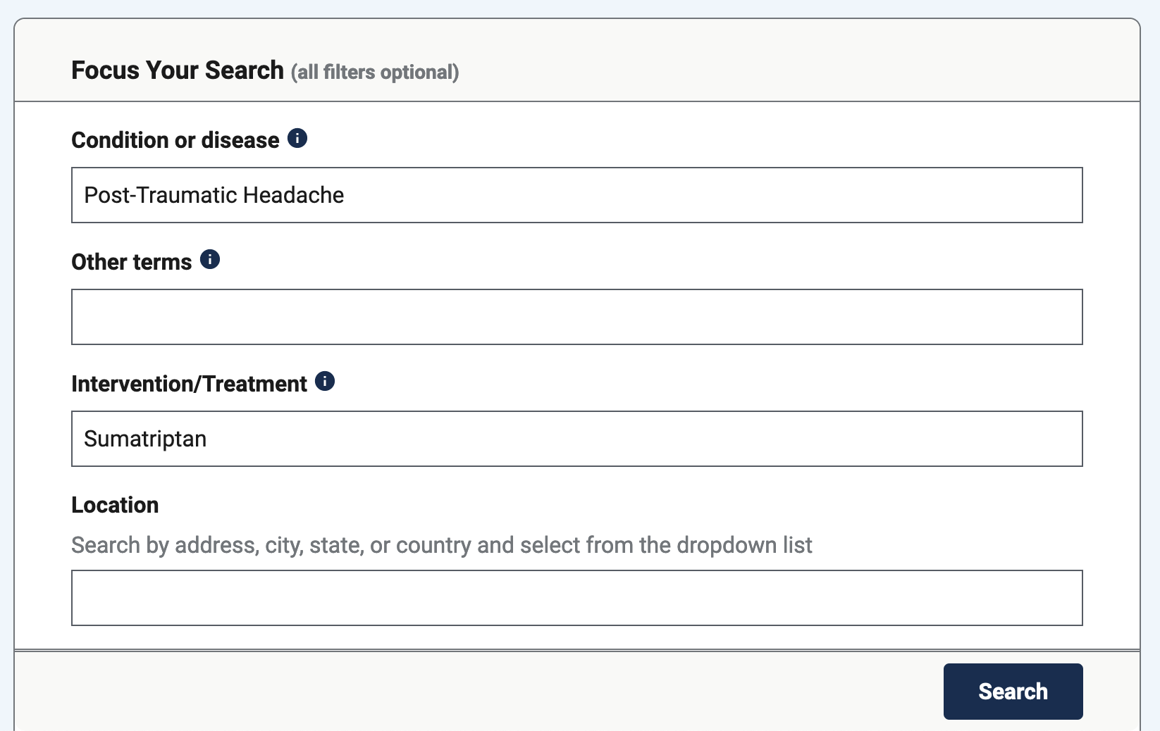

a. There is one study that is focused on sumatriptan as a single agent for treatment of post-traumatic headache. What is the title of the study?

b. Click on the study title to see the detailed info.
Find the “Collaborators and Investigators” section in the bottom third of the page.
Who is the "principal investigator"? With what institution is s/he affiliated?

c. Are study results available (check below the study header info for a "Study Results" tab)?

5. - 6.
You have a patient who makes it through a pregnancy without taking sumatriptan but thinks she could continue breastfeeding longer if she knew it was safe to take sumatriptan occasionally during breastfeeding. She asks for your opinion.

Exercise 5.
- The FDA-approved information from the drug's manufacturer/labeler(also known as the drug label or physician's prescribing info or PPI) includes information on recommended use during breastfeeding.
- Go to DailyMed (the US Government's PPI database) at https://dailymed.nlm.nih.gov/dailymed/ and search for -- sumatriptan
- Above the search results, find the drop-down menu that says “sort by relevance.” Change the setting of the menu from to “list alphabetically.”
- Find information about "IMITREX (sumatriptan succinate) tablet, film coated." If you have sorted the results alphabetically, the various Imitrex preparations should appear on the first page of results.

How long does the manufacturer suggest that Imitrex users avoid breastfeeding (Hint: Either a) check the “Use in Specific Populations” section or b) click "View all sections" link above the monograph content and use Ctl-f to find instances of the word "breast")?

Exercise 6.

- The government-compiles information (non-FDA-approved information included) about drug exposures during lactation and pregnancy in LactMed.
- Go to LactMed at https://www.ncbi.nlm.nih.gov/books/NBK501922/ and search for -- sumatriptan
- Click the link to the relevant search result. Read the "Drug Levels" section.

What is the mean half-life of sumatriptan in breast milk after a single 6 mg dose given by subcutaneous injection?

Exercise 7.
You need some information about imitrex tablet's FDA approval history and information from the pre-approval review for a presentation. This information can usually be found in the Drugs@FDA database.
- Go to the Drugs@FDA search page at https://www.accessdata.fda.gov/scripts/cder/daf/index.cfm
- Search for -- sumatriptan
- Click on the link for "Imitrex" and then the link for the -- oral/tablet form of Imitrex - sumatriptan succinate
- On the page that appears, click on the "Approval Date(s) and History..." button.
- The approval history will appear.

a) What is the earliest approval date (look at the "Original Approvals" table's "Action Date" column)?

b) What is the date of the earliest "Review" materials available through this webpage (check the "Letters, Reviews. Labels, Patient Package Insert" column of the “Supplements” table)?

Exercise 8.
You need a 3D structural diagram of sumatriptan for a presentation. You would like to show the structure with the aromatic rings to the right of the structure. PubChem provides access to 3D structural diagrams for many chemicals and allows you to change the orientation of the diagrams.
- Go to PubChem at https://pubchem.ncbi.nlm.nih.gov/
- Search for -- sumatriptan
- Click on the title of the "Best Match" search result.
- Click on the thumbnail of the 3D structure. 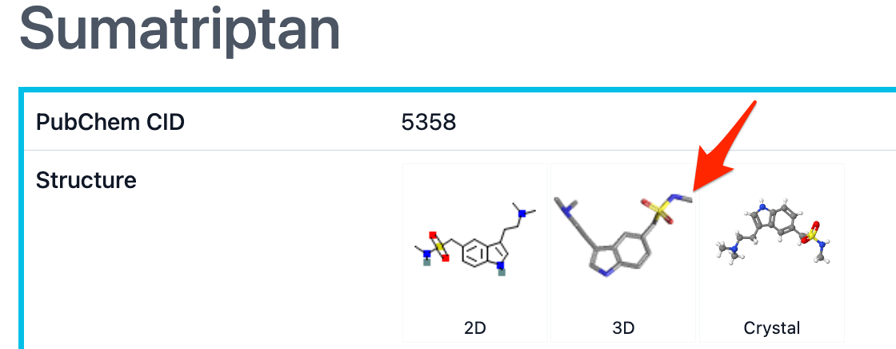
- Find the " 3D Conformer" section of the page that appears.
- Click on the "Wire-Frame" option.
- Click down on the structural diagram with your cursor and pull on the structure it to rotate it to the desired position.
- Click on "Get Image" to get a downloaded picture of the rotated structure.
- Open the downloaded file and copy the image
- Paste the image here:

