Instructions for reaching the COP Research Guide's "Patient Ed" page can be found in the course book at the end of the chapter "Freely Available, Consumer-oriented Resources"

Introduction to Questions 1 and 2

You will be dealing with questions from a breast cancer patient using MedlinePlus.
- On the "Patient Ed" page, scroll down to the fourth box, the “Patient Oriented, Health/Disease Information” box

- Click on the link to MedlinePlus.
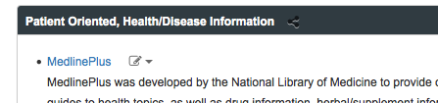

- When you reach MedlinePlus, search for –

"breast cancer"

- When search results appear, click on the link to the "National Library of Medicine" page.

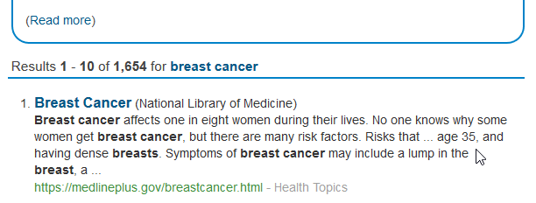
- Look over the “On this page” box to see how the information is organized.

"National Library of Medicine" pages are available for many topics. These pages categorize available links, making it easier to find the information you need.

- Scroll down the page past the introductory information to the "Start Here" section. Notice that "Spanish" links are present when a resource has both English and Spanish versions.

- Notice the “Other Languages” box on the right-hand side of the page (you may have to scroll up to see this box). This box contains a link to a list of materials in Spanish and other foreign languages.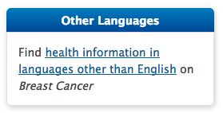
Exercise 1
A new patient, Rosalia Gomez, asks if you can help her find information about the treatment that’s been recommended to her. You learn she has stage III cancer and that her doctor has recommended she undergo neoadjuvant chemotherapy prior to surgery. Neoadjuvant chemotherapy is also called preoperative systemic therapy.
Source 1.
The first resource you are being asked to evaluate is available through the “National Library of Medicine” page for “Breast Cancer” that you located when following the introductory instructions. The needed link is In the "Treatments and Therapies" section of the page.

NCI's "Treatment Option Overview (Breast Cancer)"

Compare the general information and the information about neoadjuvant therapy (preoperative systemic therapy) available from the two sources listed below. a) Which source is most thorough? b) Which would be best for your patient, a well-educated woman who works as a social worker at a local hospital? c) Which would be best for the patient's Spanish-speaking daughter?
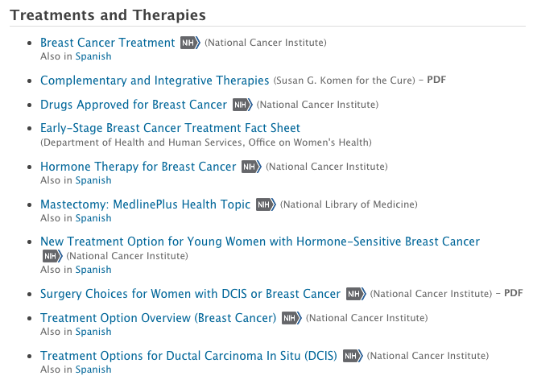

Source 2.
Open a new browser tab to go to the second resource.
The second resource you're being asked to evaluate is the
NCCN Breast Cancer Guideline for Patients.

For reasons unknown to the author of this assignment, MedlinePlus has never provided links to the NCCN guidelines.

To save time today, you can use the link below to find the needed NCCN guide.
https://www.nccn.org/patientresources/patient-resources/guidelines-for-patients/guidelines-for-patients-details?patientGuidelineId=16

In the future:
You can go to the COP Library Guide.
Go to the “Patient Education” page of the COP Library Guide.
Go to the “Patient-oriented Cancer Information” box.
Click the link to the National Comprehensive Care
Click the tab for “Guidelines for Patients”.
Scroll down to find the guideline for invasive breast cancer.

If going through the COP Research Guide,
you would follow the path shown in the
figures below:
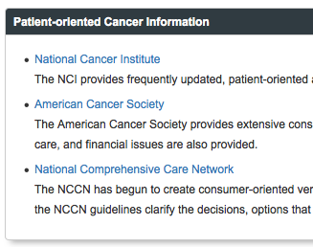

Evaluate the information from the two sources using the following criteria for evaluating consumer-oriented information:

- Content
  - Is it available in the needed languages (Spanish and English)?
  - is it accurate? (Who is supplying the information? Are they trying to sell something? Later in your career (or when you have more time), you will also need to consider whether the information in agreement with information you've found from professional-level sources?)
  - does it meet the patron’s needs?
    - topic coverage
    - illustrations, tables, charts
    - language
    - reading level
- Timeliness
  - has it been updated to reflect any recently published research/evidence/practice guidelines?
- Trustworthiness of the Source
  - do you want your patient to use the website again in the future?
  - Some recommend looking for HonCode certification before trusting a website. For the Intro to DI exam, the info you need to remember about the HonCode is: a) HonCode certification only indicates that information is being provided in an ethical manner. It does not mean that the information is accurate. and b) not all reputable websites take the time to apply for certification. ⭐

Info about the HonCode Principles below is for your review. You do not need to memorize these for the exam:

HonCode Principles:
1. Website indicates the qualifications (or lack of qualifications) of the authors
2. Website indicates that information should support, not replace, the doctor-patient relationship
3. Website respects the privacy and confidentiality of personal data submitted to the site by the visitor
4.Website cites the source(s) of published information (could cite personal experience). Dates medical and health pages.
5. Site backs up claims relating to benefits and performance (again, personal experience could be cited)
6. The presentation is accessible and an accurate e-mail address for the website publisher/author is provided
7. Funding sources are identified
8. The website clearly distinguishes advertising from editorial content
Which of the two sources do you think would be most helpful to the patient? Which would be most helpful to the patient’s daughter?

Exercise 2
A couple weeks after your first meeting, Mrs. Gomez asks for information about turmeric, an herbal supplement, and trastuzumab, a drug treatment she might need in the future. Search MedlinePlus for information about turmeric and trastuzumab.

Do you think the information available through MedlinePlus would meet the patient's needs? Why or why not?

For the Intro to DI exam, you should remember that MedlinePlus provides links to consumer-oriented disease information, herbal/supplement info, and consumer-oriented drug information. ⭐ The information available through MedlinePlus is produced by authoritative sources but may not always be up-to-date and or adequate for your patients' needs.

Exercise 3
Rosalia Gomez returns to the pharmacy again. After talking with other patients, she has decided that she wants to review the results of the research on neoadjuvant therapy in breast cancer. You don't have access to all the full-text journals that would be needed to answer your patient's question (or the time to do the research).

You remember that a consumer question research service is mentioned on the COP Library Guide's “Patient Ed” page. You tell her about the program (called the UNMC Health Information Service). You mention that UNMC librarians will research personal health/medical questions for anyone living in Nebraska (or any patient of Nebraska Medicine regardless of state of residence). The librarians will gather consumer-level and/or professional-level material for her and then send it to her without charge through e-mail or the U.S. mail. ⭐

You tell her that you could call the question in to the library and ask the UNMC Health Information Service to send materials to the pharmacy or that she could contact the the UNMC Health Information Service directly. ⭐ She says she'll e-mail the Library today.

What e-mail address should your patient use when she submits her request? (Look at the top of the "Patient Education" page of the "COP Library Guide" to find information about the UNMC Health Information Service program.)

Later you ask Mrs. Gomez about the information she received. She says it was helpful and says that she has contacted the UNMC Health Information Service for several family members who needed medical/health information.

