Resource Title  Print/Online | Picture/Call  number | Type of question(s) most often answered by  this text | Organization of  printed version | Advantages | Limitations
AHFS Drug Information =  AHFS DI  Print and Online  Up-to-date online form available through our LexiComp license | 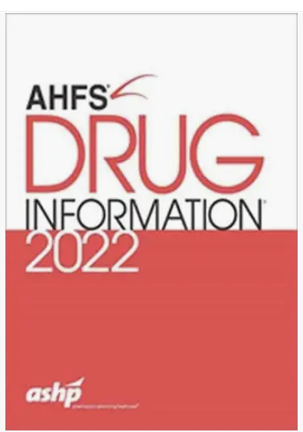  QV 740 AA1 A512  Since the library buys this resource in online form, the print version is only purchased as the budget allows (rarely). | -Dosing and administration  -Adverse effects  -Therapeutic use(s)  -Pharmacology  -Chemistry and stability  -Precautions/contraindications/warnings  -Drug/lab test interactions  -Acute/chronic toxicity  -Pharmacokinetics  -Available preparations  -Patient counseling points | -Pharmacologic- Therapeutic classification  -Index at back of text | -Provides information about both FDA and non- FDA approved uses of medications  -Annual update  -Many classes/subclasses begin with an overview which often provides valuable comparisons of class members  -Often provides “pearls” of information that are difficult to find elsewhere  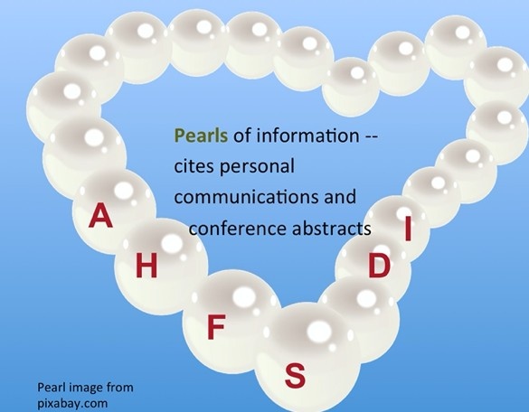 | Online version has advantages  -Some monographs only available in online version  -in-text citations are only included in the online version  -Monographs are long (availability of Ctl-f – find feature – in online version is important)
Clinical Pharmacology  Online only |  | -Dosing and administration  -Adverse effects  -Therapeutic use(s)  -Pharmacology  -Chemistry and stability  -Precautions/contraindications/warnings  -Drug/lab test interactions  -Acute/chronic toxicity  -Pharmacokinetics  -Available preparations  -Patient counseling points |  | -Provides information about both FDA and non- FDA approved uses of medications  -pediatric and adult monographs  -custom adverse effects reports  -custom consumer-level drug interaction reports  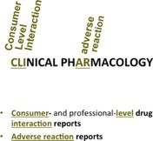
-custom professional-level drug interaction reports
-custom IV compatibility
reports

Resource Title  Print/Online | Picture/Call  number | Type of question(s) most often answered by  this text | Organization of  printed version | Advantages | Limitations
Drug Facts & Comparisons  Online only  (Book version hasn't been published since 2017) |  | -Comparisons of agents within a class or among formulations of the same active ingredient  -Indications, including some non-FDA labeled uses  -Dosing  -Warnings/Precautions/Contraindications  -Drug interactions  -Adverse reactions  -Toxicity/treatment recommendations  -Patient counseling information  -Canadian drug names | -Organized by therapeutic class  -Alphabetic index also provided | --Provides information about both FDA and non- FDA approved uses of medications  Provides excellent comparative tables  -Provides information about both OTC and Rx- only products  -Includes information on infant formulas, other enteral nutrition products  -Provides limited information about orphan drugs
Adult Drug Information Handbook (print) =  LexiDrugs (online)  Print and  Online through LexiComp | 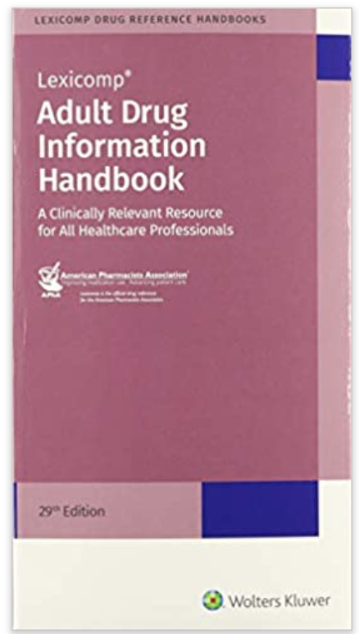  QV 735 D794 | -Dosing and administration (including dietary considerations)  -Adverse effects  -Therapeutic use(s)  -Look-alike-sound-alike medications  -Mechanism of action  -Stability, recommended preparation  -Pharmacokinetics/dynamics  -Drug/alcohol/herbal interactions  -Monitoring parameters  -Available dosage forms | -Alphabetically by generic name  -pharmacologic category index | -Provides information about both FDA and non- FDA approved uses of medications  -Useful tables/appendices (comparative charts, common CYP 450 drug interactions, no-crush drugs, etc.)  -Includes some extemporaneous compounding formulas  -Print is small , inexpensive  -Monographs fairly succinct | Online version has advantages  -in-text citations only included in the online version  -Only the online version provides cost information  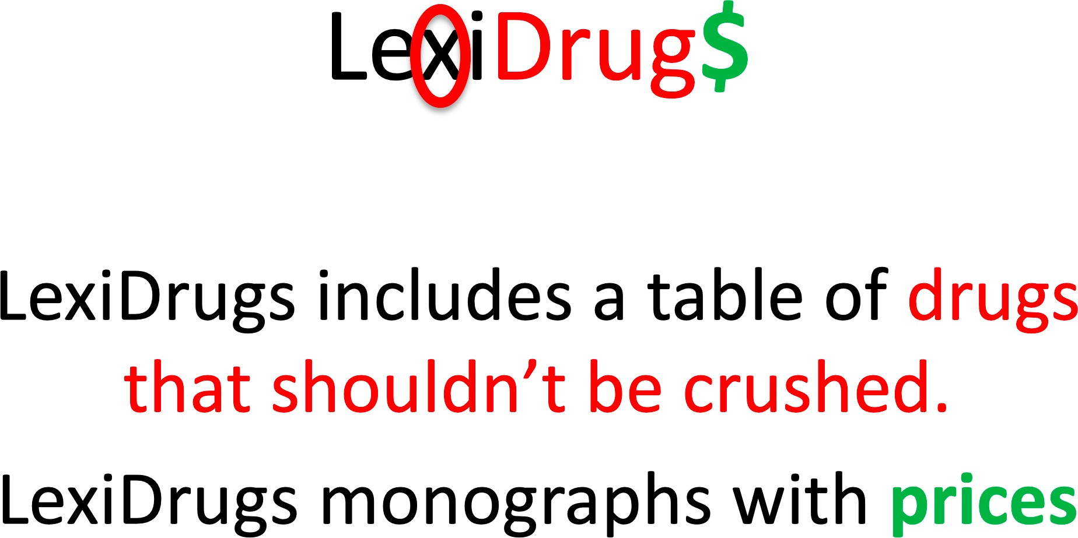
LexiComp  online only |  | -to compare monographs from different compendia after a single search.  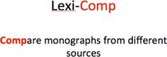 |  | -custom professional-level drug interaction reports  -custom IV compatibility reports | LexiComp mobile app (including Lexidrugs) is expensive and not included in the UNMC license.

