General Tertiary Drug Information Resources

Key to emphasized points:
Underlined, non-italicized, red font = distinctive characteristics that will probably be covered on exams and quizzes
Underlined, italicized, black font = format information and other information that may also be covered on exams.

None of the resources listed below is limited to FDA-approved uses. In other words, all may include off-label uses. DailyMed, a resource not listed below, is the only resource we will address in this class that is limited to FDA-approved uses.

Resource Title  Print/Online | Type of question(s) most often answered by  this text | Organization of  printed version | Advantages | Limitations
Clinical Pharmacology  Online only | -Dosing and administration  -Adverse effects  -Therapeutic use(s)  -Pharmacology  -Chemistry and stability  -Precautions/contraindications/warnings  -Drug/lab test interactions  -Acute/chronic toxicity  -Pharmacokinetics  -Available preparations  -Patient counseling points |  | -Provides information about both FDA and non- FDA approved uses of medications  -pediatric and adult monographs  -custom adverse effects reports  -custom consumer-level drug interaction reports  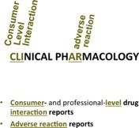  -custom professional-level drug interaction reports  -custom IV compatibility  reports
UpToDate LexiDrug  Online only | -Unites different monograph sets in a single searchable interface  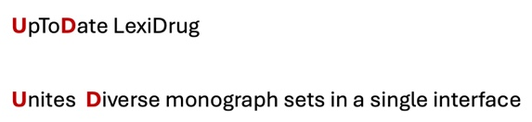 |  | -custom professional-level drug interaction reports  -custom IV compatibility reports | UpToDate LexiDrug mobile app (including Lexidrugs) is expensive and not included in the UNMC license.
LexiDrugs (online)  =  Adult Drug Information Handbook (print)  Online available through UpToDate LexiDrug  and  Print version available in the Library  QV 735 D794 | -Dosing and administration (including dietary considerations)  -Adverse effects  -Therapeutic use(s)  -Look-alike-sound-alike medications  -Mechanism of action  -Stability, recommended preparation  -Pharmacokinetics/dynamics  -Drug/alcohol/herbal interactions  -Monitoring parameters  -Available dosage forms | -organized alphabetically by generic name  -pharmacologic category index | -Provides information about both FDA and non- FDA approved uses of medications  -Useful tables/appendices (comparative charts, common CYP 450 drug interactions, no-crush drugs, etc.)  -Includes some extemporaneous compounding formulas  -Print is small , inexpensive  -Monographs fairly succinct  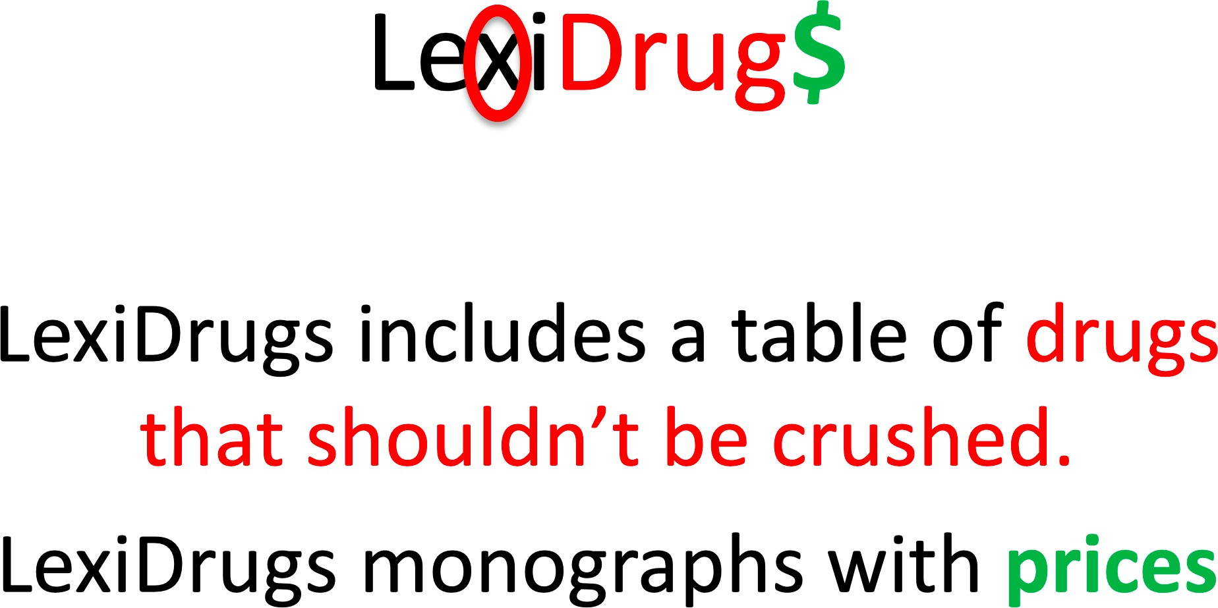 | Online version has advantages  -in-text citations only included in the online version  -Only the online version provides cost information
AHFS DI  (online)  =  AHFS Drug Information (print)  Online available through our UpToDate LexiDrug license  and  Print version in the Library  QV 740 AA1 A512 | -Dosing and administration  -Adverse effects  -Therapeutic use(s)  -Pharmacology  -Chemistry and stability  -Precautions/contraindications/warnings  -Drug/lab test interactions  -Acute/chronic toxicity  -Pharmacokinetics  -Available preparations  -Patient counseling points | -organized by therapeutic class  -Index available in printed and online version | -Provides information about both FDA and non- FDA approved uses of medications  -Annual update  -Many classes/subclasses begin with an overview which often provides valuable comparisons of class members  -Often provides “pearls” of information that are difficult to find elsewhere  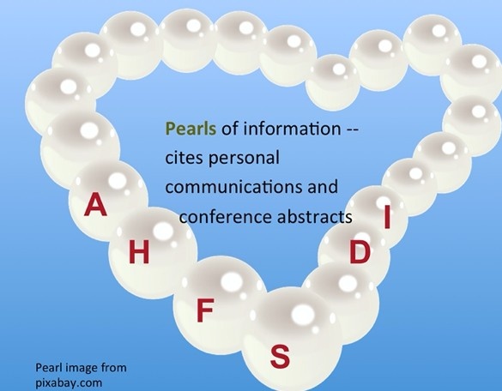 | Online version has advantages  -Some monographs only available in online version  -in-text citations are only included in the online version  -Monographs are long (availability of Ctl-f – find feature – in online version is important)
Martindale: The Complete Drug Reference  Online available through our UpToDate LexiDrug license  (Print no longer available in our library. Will not be published in print after 2024. | -Drug Name (English and foreign generic names, scientific names, CAS registry number, US and foreign proprietary names)  -Dosing and administration  -Adverse effects  -Precautions  -Interactions  -Pharmacokinetics  -Therapeutic use | -Index available in printed and online version | 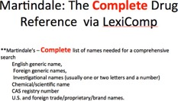
Drug Facts & Comparisons  Online only  (We don’t have access to this resource at UNMC) | -Comparisons of agents within a class or among formulations of the same active ingredient  -Indications, including some non-FDA labeled uses  -Dosing  -Warnings/Precautions/Contraindications  -Drug interactions  -Adverse reactions  -Toxicity/treatment recommendations  -Patient counseling information  -Canadian drug names | -Organized by therapeutic class  -index available in printed and online versions | --Provides information about both FDA and non- FDA approved uses of medications  Provides excellent comparative tables  -Provides information about both OTC and Rx- only products  -Includes information on infant formulas, other enteral nutrition products  -Provides limited information about orphan drugs

