Specialty Drug Information Resources

Resource Title Print/Online | Picture/Call number | Type of question(s) most often answered by this text | Organization of text/Availability  of Index | Advantages | Limitations
Drugs in Pregnancy and Lactation (Briggs')  Print and Online  Online form available via LexiComp | 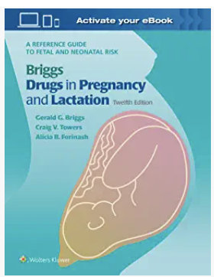  QV 4 854d | -Recommendations regarding use of medications in pregnant or lactating women | -Alphabetically by generic name  -Alphabetic index also provided | -Well referenced, well researched  -Provides recommendation for use in both pregnancy and breastfeeding  -Provides American Academy of Pediatrics recommendation when available  -Provides animal data in cases where data in humans is lacking | -Although the latest edition contains over 1180 monographs, not all drugs available in the U.S. are included  -Little information available regarding herbal products or nutritional supplements
Geriatric Dosage Handbook (print) =  Geriatric LexiDrugs (online)  print and online  Online form available via  LexiComp | 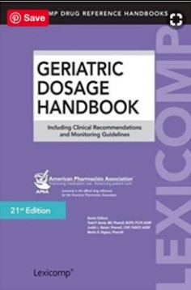  QV 735 S472 | - Same type of information as Drug Information Handbook but with a geriatric focus | -Alphabetically by generic name  -Index also provided, organized by pharmacologic category | -Provides information about both FDA and non- FDA approved uses of medications  -Useful appendices  -Portable, inexpensive  -Monographs fairly succinct | -in-text citations only included in the online version
ASHP® Injectable Drug Information : a comprehensive guide to compatibility and stability= Handbook on Injectable Drugs=  Trissel’s  ______________  Print and  Basis for IV Compatibility reports in Clinical Pharmacology and in LexiComp | 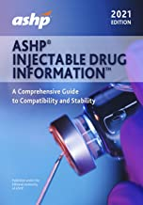  QV 786 T837h | -Compatibility of IV and injectable medications | -Alphabetically by generic name  -Alphabetic index also provided | -Information provided in tables and charts  -Well referenced  -Updated regularly | -Must understand how to appropriately interpret charts - especially in printed version.  --Online custom compatibility reports in CP and LexiComp are based on the same data and are much easier to read

Johns Hopkins ABX Guide  ______________  Online only,  on-campus only  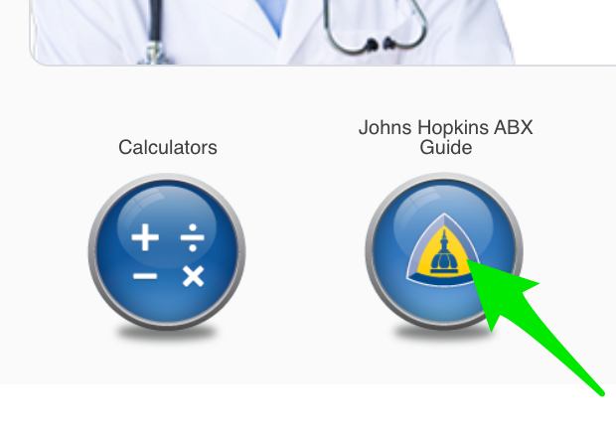 |  | -Recommendations for best choice of therapy for different infections  -Dosing for different ages and clinical conditions (kidney or liver failure) |  | Easy to use | not available off-campus
Natural Medicine Comprehensive Database  Online only  Hospital has a license to online form. |  | -Summary of information available for various dietary supplements and herbal agents, alternative therapies  -Common supplement/herbal names  -Common uses  -Dosage/administration  -Safety  -Effectiveness  -Likely mechanism of action  -Adverse reactions  -Interactions  -Commercially available products, including those that are USP verified |  | -Extensive editorial and review panel  -Well researched, well referenced  -Updated regularly
NEOFAX  ______________  Online only Nebraska Medicine has a license (we may next year) |  | -Information specific to neonatal patients including premature neonates  GOLD STANDARD REFERENCE for NEWBORNS  -Dosing  -Administration  -Monitoring  -Adverse effects/precautions  -Special considerations for neonates  -IV compatibility | -Organized by major pharmacologic category, alphabetized within  -Alphabetic index also provided | -Helpful appendices (recommended concentrations for administration, conversion tables)  -Information about infant formulas included
Pediatric & Neonatal Dosage Handbook  Print and Online  Online form is "Pediatric & Neonatal LexiDrugs" available via LexiComp | 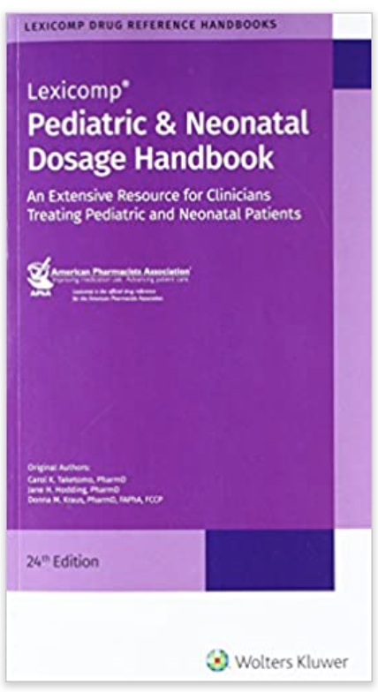  QV 735 P371g | -Same types of info as Drug Information Handbook , but with pediatric & neonatal focus | -Alphabetically by generic name  -Index also provided, organized by pharmacologic category | -Provides information about both FDA and non- FDA approved uses of medications  -Some extemporaneous compounding formulas for non-commercially available formulations provided  -Useful appendices  -Portable, inexpensive  -Monographs fairly succinct | -in-text citations only included in the online version

