Specialty Tertiary Drug Information Resources

Key to emphasized points:
Underlined, non-italicized, red font = distinctive characteristics that will probably be covered on exams and quizzes
Underlined, italicized, black font = format information and other information that may also be covered on exams.

None of the resources listed below is limited to FDA-approved uses. In other words, all may include off-label uses.

Resource Title Print/Online | Type of question(s) most often answered by this text | Organization of text/Availability of Index | Advantages | Limitations
Drugs in Pregnancy and Lactation (Briggs')  online  available via UpToDate LexiDrug  and  Print version available in the Library  QV 4 854d | -Recommendations regarding use of medications in pregnant or lactating women | -Organized alphabetically by generic name  -Index also provided | -Well referenced, well researched  -Provides recommendation for use in both pregnancy and breastfeeding  -Provides American Academy of Pediatrics recommendation when available  -Provides animal data in cases where data in humans is lacking | -Although the latest edition contains over 1180 monographs, not all drugs available in the U.S. are included  -Little information available regarding herbal products or nutritional supplements
Geriatric LexiDrugs  Online only  available via UpToDate LexiDrug | - Same type of information as Drug Information Handbook but with a geriatric focus |  | -Useful appendices  -Monographs fairly succinct
IV compatibility reports in Clinical Pharmacology and in UpToDate  =  ASHP® Injectable Drug Information : a comprehensive guide to compatibility and stability (print)  =  Trissel’s (print)  available online as the basis for the IV compatibility reports in Clinical Pharmacology and in UpToDate LexiDrug  and  Print available in the Library  QV 786 T837h | -Compatibility of IV and injectable medications | -Alphabetically by generic name  -Index also provided in the printed version | -Information provided in tables and charts  -Well referenced  -Updated regularly | -Must understand how to appropriately interpret charts - especially in printed version.  --Online custom compatibility reports in CP and UpToDate LexiDrug are based on the same data and are much easier to read than the print version of Trissel’s
Johns Hopkins ABX Guide  (abx is an abbreviation for antibiotics)  Online only  on-campus only, may work on your tablet computers  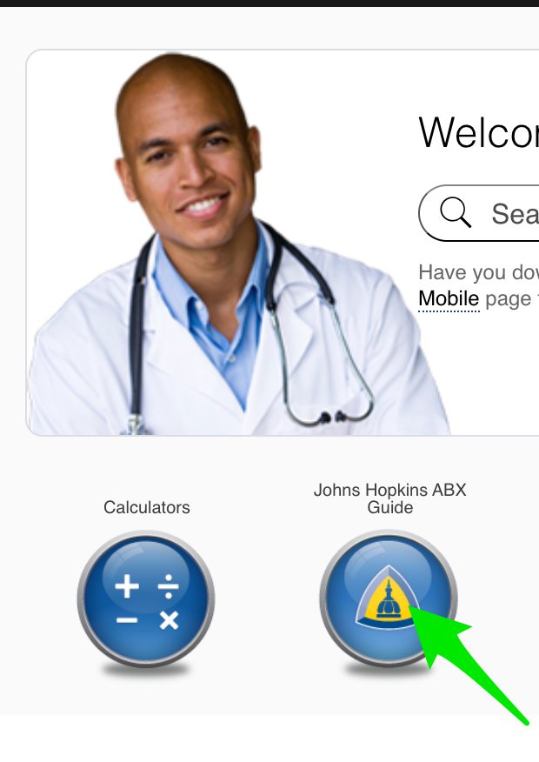 | -Recommendations for best choice of therapy for different infections  -Dosing for different ages and clinical conditions (kidney or liver failure) |  | Easy to use | not available off-campus
Natural Medicine Comprehensive Database  Online only  Nebr. Med. (hospital) has a license to online form. | -Summary of information available for various dietary supplements and herbal agents, alternative therapies  -Common supplement/herbal names  -Common uses  -Dosage/administration  -Safety  -Effectiveness  -Likely mechanism of action  -Adverse reactions  -Interactions of herbals/supplements/etc. with drugs  -Commercially available products, including those that are USP verified |  | -Extensive editorial and review panel  -Well researched, well referenced  -Updated regularly
NEOFAX  Online only  Nebraska Medicine has a license | -Information specific to neonatal patients including premature neonates  GOLD STANDARD REFERENCE for NEWBORNS, especially PREMATURE babies  -Dosing  -Administration  -Monitoring  -Adverse effects/precautions  -Special considerations for neonates  -IV compatibility | -Organized by major pharmacologic category  - | -Helpful appendices (recommended concentrations for administration, conversion tables)  -Information about infant formulas included
Pediatric & Neonatal LexiDrugs (online)  =  Pediatric & Neonatal Dosage Handbook (print)  Online  and  Print version available in the Library  QV 735 P371g | -Same types of info as Drug Information Handbook , but with pediatric & neonatal focus  Not as good for premature neonates as NEOFAX | -Organized alphabetically by generic name  -Index also provided, organized by pharmacologic category | -Some extemporaneous compounding formulas for non-commercially available formulations provided  -Useful appendices  -Portable, inexpensive  -Monographs fairly succinct | -in-text citations only included in the online version

