Tertiary Resources Assignment (8 questions, 3 pages). Name_______________________________

1. Use a resource available on UNMC's campus that is entirely focused on antibiotic therapy to respond to #1.
A new resident asks you for the best treatment to use in a 12-month-old child with severe acute ear infection in both ears (severe, bilateral acute otitis media). The child hasn't received any antibiotics.

- Which tertiary resource should be used?

- What is the appropriate antibiotic, dose, dosing interval, and duration of therapy?

2. Use a resource that focuses on drug use by pregnant and breastfeeding mothers to answer question #2.
If the folate acid antagonist, pyrimethamine, is given during pregnancy to treat maternal/fetal toxoplasmosis, what dose of folic acid or folinic acid must also be given (hint: Search LexiComp for pyrimethamine. Scroll to the botom of the page of search results to find the needed monograph link.)?

- Which tertiary resource should be used?

- If folic acid is preferred for use with pyrimethamine, what folic acid dose should be used?

- If folinic acid is preferred for use with pyrimethamine, what folinic acid (leucovorin) dose should be used?

3. Use a resource that provides pearls of information that are frequently not included in other resources.
You have an HIV-infected patient who thinks he could take his ritonavir oral solution more easily if he could add it to his Advera nutritional supplement. Will this administration method affect the absorption of ritonavir (Hint: Search for the ritonavir monograph and open it --be sure to use the correct resource. Then use the ctl-f or command-f (Mac) to open a “Find” box and search for the name of the nutritional supplement. Check all mentions of Advera to find the reference to bioavailability. )?

- Which tertiary resource should be used?

- Will dilution in Advera affect bioavailability of ritonavir?

- How quickly should the diluted drug be used?

- Look at the references cited as the source for the information about the bioavailability of ritonavir in Advera. Was a conference abstract or personal communication cited?

4. Use a resource that includes a list of the medications that should not be crushed.
A patient’s husband calls to ask if he can crush his wife’s Evista (Raloxifene) tablets. He thinks they will be easier for her to swallow if crushed and taken with water.

Search LexiComp for the word – crushed . One of the results that appears will be a table of drugs that should not be crushed that is available through the resource of interest. Click on the link to the table, and look for Evista. Be sure to read relevant footnotes (if any) as well as the table entry

- Is it okay to crush Evista?

- If not, why not?

- Which tertiary resource did you use?

5. Use an online, major drug information resource that allows preparation of custom, adverse effect reports.

One of your patients has been taking azacitidine for RAEB (refractory anemia with excess blasts ) for over a year. Her life has been stressful and the accumulated stress led, 6 months ago, to the onset of a major depressive episode that was treated with duloxetine (Cymbalta). Duloxetine was chosen because it also has some analgesic effect in neuropathic pain, one of your patient’s many problems. The only other prescription drug she is taking at the moment is moexipril for hypertension. This was started 6 weeks ago. For the last 5 weeks she has had a dry cough that is keeping her up at night. She is in desperate need of sleep. She hasn’t had any other cold or flu symptoms and is taking no non-prescription drugs or supplements at the moment. Which of the patients drugs may be causing the cough, if any.
Create a custom, adverse effects report for your patients medication list.

a. Which, if any, of her medications could be causing her cough?

b. Based on the patient’s history, which medication do you think is most likely to be causing cough in this patient’s case?

b. Which resource did you use?

********************************************
A few quick questions to introducea few non-drug-centered resources that you may find helpful:
I want you to be aware of several more resources. I used to introduce these resources during a P2 pharmacotherapy lab, but this lab has been discontinued. These are professional, disease-focused resources; not drug-focused resources. You will not be tested on these resources, but will probably find them useful during your time here at UNMC.

General background for 6-7
Most of these resources are available through the "Clinical Resources" button on the Library's homepage and in the "Clinical Resources" portion of the COP Research Guide homepage (see screenshot below).
6. background:
The Access Medicine/Surgery/etc. resources are online textbook collections. Those listed under "Clinical Resources" are targeted largely at medical students, and physician interns and residents.

If you need to learn something that a medical student would learn during med school, AccessMedicine is a good place to start. It includes basic science and clinical texts.

6. question:
Search AccessMedicine for --
orthostatic blood pressure
Find an online book that provides step by step instructions for measuring orthostatic blood pressures. There are several; just locate one. What are the book and chapter titles?

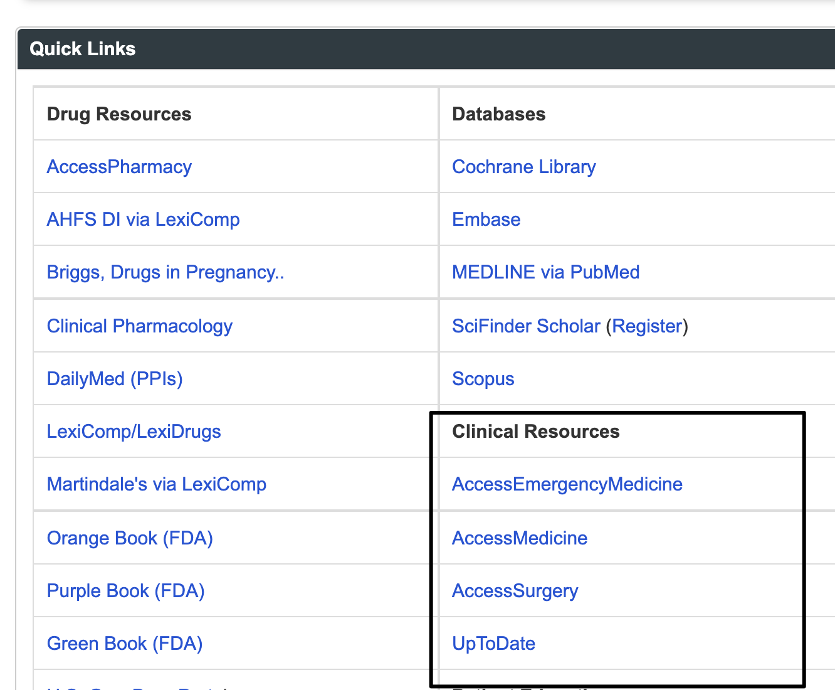

7. background:
UpToDate is made up of frequently updated, peer-reviewed overviews of information available on a wide range of health/medical topics. UpToDate is useful to students, but really targeted at physicians in training and physicians in practice and is useful to subspecialists as well as primary care physicians. Pharmacists were among the first affiliates who urged Nebraska Medicine to license this resource -- so, obviously, it's useful to pharmacists too.

7. question:
- Search UpToDate for --
orthostatic blood pressure
-- open the article about mechanisms and evaluation of orthostatic hypotension (low blood pressure).
- Scroll toward the bottom of the left-hand navigation column to find the "Graphics" section. Find a graphic that would be helpful to you if you needed to teach a group of students about the best approach to treating orthostatic hypotension. What is the title of the graphic?

8. background:
Practice guidelines are generally written by large groups of acknowledged experts and are often based on very thorough literature database searches. Their production is often sponsored by a professional organization.

The US Government used to fund a guideline database, but that funding ended several years ago. Currently there is no recognized "best" place to search for guidelines. Since many guidelines are not published in journal articles, a search of a standard literature database like PubMed is not enough.

A Google search for guidelines can help you identify important guidelines. In addition to important guidelines authored by professional organizations, a Google search will also identify less important guidelines authored by individual hospitals as well as articles that just mention guidelines. You have to evaluate the articles you find before using them to guide practice.

A link to a Google search for guideline is available on the COP Research Guide. (You will learn more about how to develop this type of search strategy during the "internet" session.)

8. question:
- Go to the COP Research Guide

- Click the "Evidence-based Medicine" tab.
- Scroll down to the "Practice Guidelines" box and click the "Google Guideline Search" link.

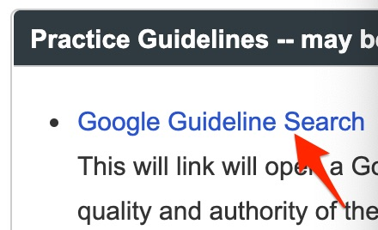

- A search for the guideline-associated title words will appear.
- Place your cursor at the beginning of the search box (in front of the existing terms).
- Type -- "orthostatic hypotension" syncope -- at the beginning of the search box (include the quotation marks). "Syncope" means fainting.

This search will identify a 2017 guideline dealing with syncope (fainting) that gives some attention to orthostatic hypotension . Name one of the organizations responsible for authoring this guideline:

