**Tertiary Resources Assignment (8 questions, 3 pages).** Name_______________________________

Complete the interactive exercise at the [**end** of the third chapter of the course book](https://pressbooks.nebraska.edu/introtodi/chapter/2-additional-important-print-and-online-resources/) before answering questions 1-5 below. Completing this exercise should insure that you use the correct resources to answer questions 1-5.

1. **Use a resource available on UNMC's campus that is entirely focused on antibiotic (ABX) therapy to respond to #1.**

A new resident asks you for the best treatment to use in a 12-month-old child with severe acute ear infection in both ears (severe, bilateral acute otitis media). The child hasn't received any antibiotics.

1. **Which tertiary resource should be used?**

*(When on campus, you may be able to use this resource using your tablet computer, or you may need to use a networked computer on campus – like one of the teaching computers or the computers in the library’s computer cluster. Either the link for this resource on the Library's "Drug Resources" page or the link to the resource on the COP Research Guide available through the "Library" link in Canvas). On the initital page you reach, find the round button for this resource. Search for the disease name (pediatric otitis). This resource has pediatric-focused and adult-focused articles/chapters. Be sure to find the pediatric article to answer this question).*

1. **What is the appropriate antibiotic, dose, dosing interval, and duration of therapy?**

2. **Use a resource that focuses on drug use by pregnant and breastfeeding mothers to answer question #2.**

If the folate acid antagonist, pyrimethamine, is given during pregnancy to treat maternal/fetal toxoplasmosis, what dose of folic acid or folinic acid must also be given?

(*Hint: Search the UpToDate LexiDrug interface for pyrimethamine. Scroll to the botom of the page of search results and click the “more results” link to find the monograph link for the appropriate resource*. *Once you reach the pyrimethamine monograph, use Ctl-f (Windows) or Command-f (mac) to open a "Find" box and then search for instances of "foli”.)*

1. **Which tertiary resource should be used (name both the resource used and the interface searched)?**
2. **If a physician decides to use folic acid with pyrimethamine, what folic acid dose should be used?**
3. **If a physician decides to use folinic acid with pyrimethamine, what folinic acid (leucovorin) dose should be used?**

3.  **Use a resource that will provide the United States and foreign generic and proprietary names for a drug as well as the drug's CAS number and scientific and investigational names.**

A patient has moved to Omaha from the United Kingdom. His prescription list includes the brand name drug Uxil. What is the active ingredient in Uxil? What is the United States brand name for the single-ingredient preparation of this drug?

*(Hint: Search UpToDate LexiDrug for Uxil. Click the link under the appropriate resource's name ( If necessary, click the “More results” link to find the needed resource). Find the active ingredient’s name and record this name. Click on the active ingredient to find the monograph for that ingredient. To find the U.S. and foreign brand names, go to the "preparations: single-ingredient" section.)*

1. **Which tertiary resource should be used (name both the resource used and the interface searched)?**
2. **What is the active ingredient/drug in Uxil?**
3. **What is the United States brand name for the drug?**

4. **Use a resource that includes a list of the medications that should not be crushed.**

A patient’s husband calls to ask if he can crush his wife’s Evista (Raloxifene) tablets. He thinks they will be easier for her to swallow if crushed and taken with water.

*(Search UpToDate LexiDrug for the word – crushed . One of the results that appears will be a table of drugs that should not be crushed that is available through the resource of interest. Click on the link to the table, and look for Evista. Be sure to read relevant footnotes (if any) as well as the table entry.)*

1. **Is it okay to crush Evista?**
2. **If not, why not?**
3. **Which tertiary resource should be used (name both the resource used and the interface searched)?**

**5.** Use an **online,** **major drug information resource** that allows preparation of **custom, adverse effect reports.**

One of your patients has been taking **azacitidine** for RAEB (refractory anemia with excess blasts ) for over a year. Her life has been stressful and the accumulated stress led, 6 months ago, to the onset of a major depressive episode that was treated with **duloxetine** (Cymbalta). Duloxetine was chosen because it also has some analgesic effect in neuropathic pain, one of your patient’s many problems. The only other prescription drug she is taking at the moment is **moexipril** for hypertension. This was started 6 weeks ago. For the last 5 weeks she has had a dry cough that is keeping her up at night. She is in desperate need of sleep. She hasn’t had any other cold or flu symptoms and is taking no non-prescription drugs or supplements at the moment**.** Which of the patients drugs may be causing the cough, if any.

**Create a custom, adverse effects report for your patients medication list.**

**a. Which, if any, of her medications could be causing her cough?**

**b. Based on the patient’s history, which medication do you think is most likely to be causing cough in this patient’s case?**

**c. Which resource did you use?**

**\*\*\*\*\*\*\*\*\*\*\*\*\*\*\*\*\*\*\*\*\*\*\*\*\*\*\*\*\*\*\*\*\*\*\*\*\*\*\*\*\*\*\*\***

**A few quick questions to introduce few non-drug-centered resources that you may find helpful:**

I want you to be aware of a couple of additional resources. I used to introduce these resources during a P2 pharmacotherapy lab, but this lab has been discontinued. These are professional, disease-focused resources; not drug-focused resources. **You will not be tested on these resources**, but will probably find them useful during your time here at UNMC.

**General background for 6-7**

Most of these resources are available through the "Clinical Resources" button on the Library's homepage and in the "Clinical Resources" portion of the [COP Research Guide](https://unmc.libguides.com/cop) homepage (see screenshot below).

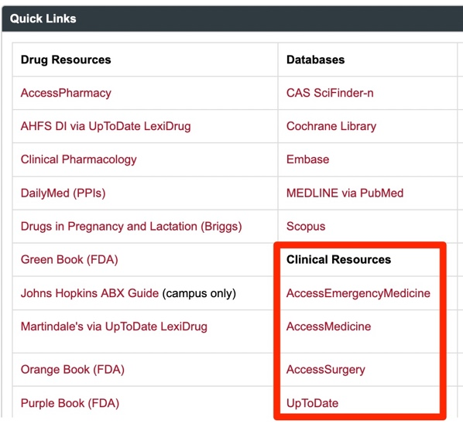**6. background:**

The Access Medicine/Surgery/etc. resources are online textbook collections. Those listed under "Clinical Resources" are targeted largely at medical students, and physician interns and residents.

If you need to learn something that a medical student would learn during med school, AccessMedicine is a good place to start. It includes basic science and clinical texts.

**6. question:**

Search **AccessMedicine** for --

**Intramuscular Z-track**

Find a book that provides an illustration of the Z-track method for intramuscular injections. **What are the book and chapter titles?**

**8. background:**

Practice guidelines are documents that guide healthcare providers and patients in making appropriate, evidence-based healthcare decisions. They are generally written by large groups of acknowledged experts and are often based on very thorough literature database searches. Their production is often sponsored by professional organizations.

Years ago, the US Government funded a guideline database. Currently there is no recognized "best" place to search for guidelines. Since many guidelines are not published in journal articles, a search of a standard literature database like PubMed is not enough.

A Google search for guidelines can help you identify important guidelines. In addition to important guidelines authored by professional organizations, a Google search will also identify less important guidelines authored by individual hospitals as well as articles that just mention guidelines (see the next page of this assignment for directions). **You have to evaluate the articles you find to determine whether they are true guidelines and whether they are based on solid evidence before using them to guide practice.**

A link to a Google search for guidelines is available on the COP Research Guide. (You will learn more about how to develop this type of search strategy during the "internet" session.)

**8. question:**

* Go to the COP Research Guide

A screenshot of the COP Research Guide showing the position of the “Evidence-based Medicine” tab.

* Click the "Evidence-based Medicine" tab.
* Scroll down to the "Practice Guidelines" box and click the "Google Guideline Search" link.

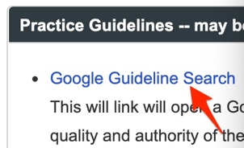

* A search for the guideline-associated title words will appear.
* Place your cursor at the beginning of the search box (in front of the existing terms).
* Type -- HCV -- at the beginning of the search to look for any guidelines that deal with treatment of hepatitis C virus (HCV)-infected patients.



**This search will identify a guideline posted on the hcvguidelines.org website. Click the link. What organizations are identified in the webpage header as the sponsors of this guideline.**