midterm 2017

Name _____________________________

Information you may want to use during the exam:

Standard Search Templates:

1.
Drug A used to prevent Disease B
"Drug A"[mesh] AND "Disease B/prevention and control"[mesh]

2.
Drug A (Procedure A) causes Disease B
(“Drug A/adverse effects”[mesh]) AND (“Disease B/etiology”[mesh])

3.
Drug A used to treat Disease B
("Drug A/therapeutic use”[mesh]) AND ("Disease B/therapy"[MeSH])

PubMed Tag Table:
Affiliation [AD]  Article Identifier [AID]  All Fields [ALL]  Author [AU] last fm[au]  Book [book]  Comment Corrections  Corporate Author [CN]  Create Date [CRDT]  Completion Date [DCOM]  EC/RN Number [RN]  Editor [ED]  Entrez Date [EDAT] | Filter [FILTER]  First Author Name [1AU]  Full Author Name [FAU] last, first[fau]  Full Investigator Name [FIR]  Grant Number [GR]  Investigator [IR]  ISBN [ISBN]  Issue [IP]  Journal [TA]  Language [LA]  Last Author [LASTAU]  Location ID [LID] | Owner  Pagination [PG]  Personal Name as Subject [PS]  MeSH Date [MHDA]  MeSH Major Topic [MAJR]  MeSH Subheadings [SH]  MeSH Terms [MH], [MeSH]  Modification Date [LR]  NLM Unique ID [JID]  Other Term [OT]  Pharamcological Action [PA]  Place of Publication [PL]  PMID [PMID] | Publisher [PUBN]  Publication Date [DP]  Publication Type [PT]  Secondary Source ID [SI]  Subset [SB]  Supplementary Concept[NM]  Text Words [TW]  Title [TI]  Title/Abstract [TIAB]  Transliterated Title [TT]  UID [PMID]  Volume [VI]

Questions 1-10. Your patient, a wildlife researcher, is hoping to travel to Madagascar with his wife and his newborn, breastfed daughter. There is currently an outbreak of pneumonic plague in the country.

Select the resource from options a-j that will best address the stated information need.
A. ClinicalTrials.gov  B. Orange Book (produced by the FDA)  C. Lexidrugs  D. MedlinePlus  E. Immunofacts | F. Yellow Book (produced by the CDC)  G. LactMed  H. Neofax  I. Clinical Pharmacology  J. PubMed Central (PMC)

1. Resource listing medicines that may be used to prevent malaria during travel in Madagascar.

2. Resource that can produce a custom, consumer-language, drug interactions report after entry of the names of your patient’s current medications and the recommended malaria-preventing medications.

3. Resource that provides price information for each of the recommended malaria prevention medications.

4. Resource that can provide therapeutic equivalence information for brand name Bactrim (trimethoprim/sulfamethoxazole) and a generic trimethoprim/sulfamethoxazole preparation with equivalent dose and dosage form.
(Bactrim can be used for plague prevention if your patient is exposed to plague while in Madagascar.)

5. Authoritative, consumer-oriented information concerning pneumonic plague, its prevention, symptoms and treatment that you can print out and give to your patient.

6. Information about the amount of the recommended malaria-preventive medications and plague preventive medications that are contained in the breast milk of breastfeeding women.

7. Recommended doses of the malaria-preventive medications and plague preventive medications for administration to a neonate.

8. An article containing “Insights into the long-term maintenance of plague” that you are told has been made available through the U.S. government’s full-text repository (the same repository that is used to make NIH-funded resource available to the US public).

9. Information on administration of rabies vaccine . Rabies vaccine is recommended for wildlife workers in Madagascar.

10. Information about an ongoing clinical trial co-sponsored by the governments of the U.S. and Madagascar.
Page Break_______________________________________________________________________________
Questions #11 – 19
A dermatologist who is well known for his work with patients who have hyperpigmented (dark) or discolored skin patches frequently calls you with questions.

Which of the resources (a-i) would be most likely to address the information needs in #11 –19?
A. AHFS Drug Information  B. Hazardous Substances Data Bank  C. Martindale: The Complete Drug Reference  D. DailyMed  E. Natural Medicines Comprehensive Database | F. Adult Drug Information Handbook /LexiDrugs  G. Drugs@FDA  H. Drugs in Pregnancy and Lactation (Briggs)  I. Drug Facts and Comparisons
11. The original review materials considered by the FDA when Tri-Luma (Fluocinolone Acetonide/Hydroquinone/Tretinoin) Cream was approved in 2002.

12. Information about a non-prescription, mulberry and orchid extract used to reduce skin pigmentation (to lighten skin color).
13. Summaries of mercury toxicity studies in humans and animals and information about the available antidotes.
(Mercury poisoning has been reported in users of skin lightening creams containing calomel (mercurous chloride).)

14. Safety of dimercaprol during pregnancy.
(Dimercaprol is a mercury chelating(binding) agent that is used as an antidote for mercury poisoning.)

15. A source providing the investigational and scientific names, CAS registry number, and the U.S. and foreign, generic and brand (trade/proprietary) names for dimercaprol.

16. FDA-approved physician’s prescribing information for a specific manufacturer’s Tretinoin cream.

17. A source with a table listing drugs that should not be crushed. The table should provide the reason that tretinoin tablets should not be crushed.

18. Information from personal communications with manufacturers or from conference abstracts concerning clindamycin phosphate, a topical treatment for acne.

19. A table comparing the anti-inflammatory activities of the available glucocorticoids (steroids).
_______________________________________________________________________________

Question #: 20

Which of the following can produce a custom, IV compatibility report?

A. LexiComp
B. Clinical Pharmacology
C. both of the above
D. neither of the above

Note: As you will see, Cindy was pre-occupied by preparations to treat age spots when she wrote this test. Why you ask?
Cindy 10 years ago. When the giant age spot was just a giant freckle.
Cindy in 2020. Lots of little age spots and the one that’s trying to take over (it looks a bit like a map of North and Central America and that’s after treatment with lightening creams).

____________________________________________________________________________

Question 21-23. A dermatologist asks the pharmacist supervising your rotation to provide instruction for the dermatology department’s house offices. He mentions three topics of specific interest. You volunteer to help with the literature searches. You decide to begin with MeSH-based searches.

21. You need to perform a MeSH-based, PubMed search for articles about the retinoids to prevent hyperpigmentation (overly dark skin). Which of the following search strategies will help you focus on relevant results and avoid retrieval of an overwhelming number of irrelevant results?

A. ( “Retinoids/prevention and control”[MeSH] ) AND ("Hyperpigmentation"[Mesh])
B. (“Retinoids/adverse effects”[MeSH]) AND (“Hyperpigmentation/etiology”[MeSH])
C. (“Retinoids”[MeSH] OR "Hyperpigmentation/prevention and control"[Mesh])
D. ( “Retinoids”[MeSH] ) AND ("Hyperpigmentation/prevention and control"[Mesh])

22. You need to perform a MeSH-based, PubMed search for articles describing kidney diseases caused by skin lightening preparations. Which of the following search strategies will help you focus on relevant results and avoid retrieval of an overwhelming number of irrelevant results?

A. ( "Skin Lightening Preparations/adverse effects"[Mesh]) AND ("Kidney Diseases/etiology"[Mesh] )
B. ( "Skin Lightening Preparations/adverse effects"[Mesh]) AND (“Kidney/drug effects”[MeSH])
C. ("Skin Lightening Preparations/therapeutic use"[Mesh]) AND ( “Kidney Diseasees/therapy”[MeSH])
D. ("Skin Lightening Preparations”[MeSH] ) AND (“Kidney/Drug effects”[MeSH])

23. You need to perform a MeSH-based, PubMed search for articles describing use of hydroquinones to treat hyperpigmentation (overly dark skin). Which of the following search strategies will help you focus on relevant results and avoid retrieval of an overwhelming number of irrelevant results?

A. ( "Hyperpigmentation/ therapeutic use"[Mesh] ) AND ("Hydroquinones/therapy"[Mesh] )
B. ("Hyperpigmentation/therapy"[Mesh] ) AND ("Hydroquinones/therapeutic use"[Mesh] )
C. ( "Hyperpigmentation/etiology "[Mesh] ) AND ( "Hydroquinones/adverse effects "[Mesh])
D. (“Hydroquinones”[MeSH]) AND (“Skin/drug effects”[MeSH])

____________________________________________________________________________

Question #: 24

The top of the MeSH database entry for the “Hyperpigmentation” heading is shown below:

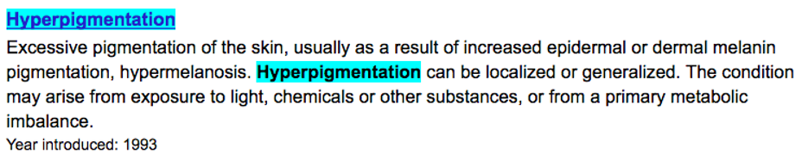

You have created the following PubMed search strategy:

“Hyperpigmentation”[mesh]

Which of the PubMed records below (a,b,c, all (a-c), or none) would you expect to be retrieved by your search strategy?

A.
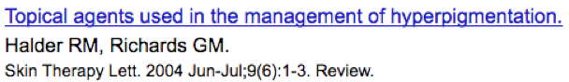
B.
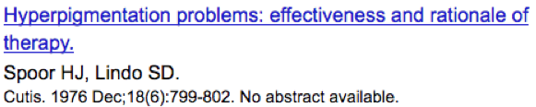
C.
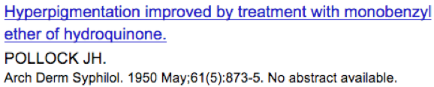
D. all of the above
E. none of the above

____________________________________________________________________________

Question #: 25

After completing the MeSH searches you decide to move on to keyword searches. You decide to begin with a quick search for articles that mention skin lightening in the article title. Your search strategy is shown below:

(skin*[ti] AND lighten*[ti])

Which of the PubMed records shown below (a,b, c, d=all, or d=none) will be retrieved by your search?

A.
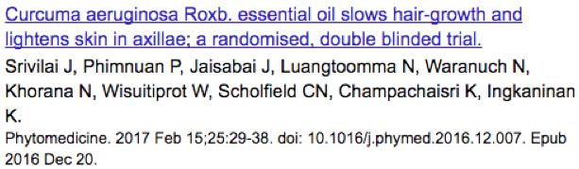
B.
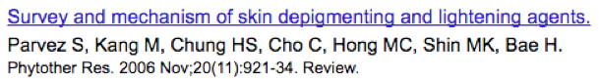
C.
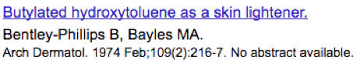
D. all of the above
E. none of the above

____________________________________________________________________________

Question #: 26

A fellow student also conducts a quick search for articles that mention skin lighteners in the article title. His search is shown below.

“skin lighteners”[ti]

Which of the PubMed records shown below (a,b,c, d=all, e=none) will be retrieved by his search?

A.
B.
C.
D. all of the above
E. none of the above

27-31. Rhofade, a cream containing oxymetazoline hydrochloride, was approved by the FDA in January 2017 for the treatment of Rosacea, a relatively common skin condition. Below are the portions of a drug information resource that provides the drug names needed for an exhaustive search. The international brand names are not included because Rhofade is the only brand name for the topically applied oxymetazoline cream of interest.

Oxymetazoline Hydrochloride

Drug Nomenclature
Form and Weight: C₁₆H₂₄N₂O,HCl = 296.8
CAS: 2315-02-8
Synonyms
H-990; Oksimetatsoliinihydrokloridi; Oksimetazolin Hidroklorür; Oksimetazolino hidrochloridas; Oximetazolin-hidroklorid; Oximetazolina, hidrocloruro de; Oximetazolinhydroklorid; Oxymetazolin hydrochlorid; Oxymetazolinhydrochlorid; Oxymetazolini Hydrochloridum; Oxymétazoline, chlorhydrate d'; Sch-9384; オキシメタゾリン塩酸塩
United States Adopted Names
- Oxymetazoline Hydrochloride
British Approved Names
- Oxymetazoline Hydrochloride [BANM]
International Nonproprietary Names
- Hidrocloruro de oximetazolina [rINNM (es)]
- Oxymetazoline Hydrochloride [rINNM (en)]
- Oxymetazolini Hydrochloridum [rINNM (la)]
- Oxymétazoline, Chlorhydrate d' [rINNM (fr)]
- Оксиметазолина Гидрохлорид [rINNM (ru)]

For the purposes of this exam, imagine that you are among a group of students who have been asked to conduct an exhaustive search for all literature concerning topical oxymetazoline.
Question #: 27
You and your fellow student begin by creating a drug keyword search.

You compose a keyword strategy using the provided information. Your search retrieves 193 results. Many of the results have nothing to do with the drug of interest. The irrelevant records usually contain a highlighted letter “H” and a highlighted number “990” in separate parts of the abstract. What should you do next?

A. Remove all forms of H-990 from your search.
B. Check above the search result list for quoted phrases not found messages. Remove any space-containing drug names that are “not found” by PubMed.
C. Add a --
[tiab]
-- tag after each form of H-990 in your search.
D. Remove all quotation marks from the search.

Question #: 28
You make the needed changes in your search. Your drug keyword search now retrieves 34 unindexed and 996 indexed search results . All are focused on oxymetazoline. Your friend asks you for help. Her search, shown below, retrieves zero results.

(oxymetazolin* OR oksimetatso* OR oksimetazol* OR oximetazolin* OR "h 990" OR H990 OR h-990 OR rhofade OR Sch-9384 OR sch9384OR "sch 9384") NOT MEDLINE[sb]

What type of problem is causing zero result retrieval?

A. The –
NOT MEDLINE[sb]
-- should be removed. It is preventing retrieval of unindexed results.
B. All quotation marks should be removed.
C. oxymetazoline should not be truncated.
D. There is a problem with the position or choice of one or more of the operators (AND, OR, NOT).
E. The various versions of hydrochloride should be OR’d into the search.
F. There is a problem with the position or number of parentheses.

Question #: 29
Another student is looking for alternate terms for the “topical administration” concept. Which of the following steps below (a,b,c, or all (d)) might provide useful alternate terms for the "topical" concept?

A. Reviewing portions of the MeSH database entry for “Administration, Topical” including the heading definition, the “Entry Term” list and any narrower headings.
B. A Google search for –

topical synonyms OR “related terms”

C. Scanning the titles and abstracts of your initial search results for additional words/phrases that indicate a discussion of topical administration.
D. All of the above

Question #: 30
After compiling a list of alternate terms for the “topical administation” concept, your friend adds the English generic name for oxymetazoline to her search. She just wants to see what kind of results are retrieved by a two-concept search. All the results of her search mention the topical administration concept. However, after scanning the first 200 results, she has yet to find a single result that mentions oxymetazoline.

(oxymetazolin*[ti] AND topical OR transcutaneous OR transdermal OR skin OR cutaneous OR dermal OR epidermal OR creme OR cream OR salve OR ointment*)

What’s wrong with your friend’s search?

A. There is a problem with the position or choice of one or more of the operators (AND, OR, NOT).
B. There is a problem with the number or positions of parentheses.
C. The --
[ti]
–tag after oxymetazolin* is preventing retrieval of results concerning oxymetazoline.
D. There is nothing wrong with the search.

Question #: 31
Another friend has worked on the search using PubMed’s advanced search page. His search is retrieving zero results. This friend’s search table is shown below:
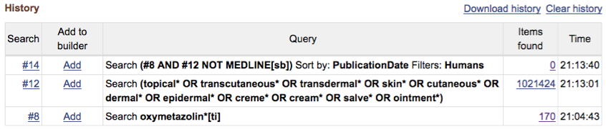

Why are zero results being retrieved?

A. Oxymetazoline should not be truncated.
B. There is a problem with the number or positions of parentheses.
C. There is a problem with the use of operators (AND, OR, NOT)
D. There is a problem involving the filter applied to search #14.

_____________________________________________________________
A screenshot of the MeSH tree containing the “Pharmaceutical Services” heading is shown below.
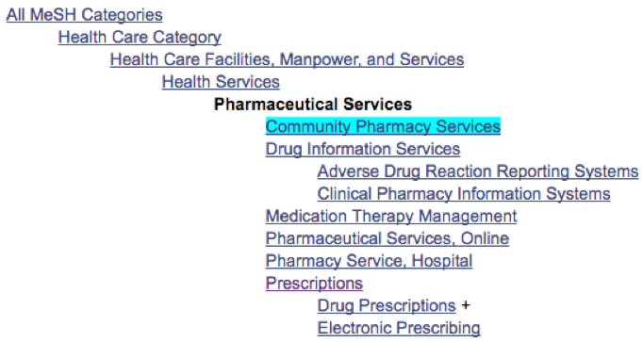

Determine whether the statements in #32 - #35 below are True or False by referring to this tree:

Question #: 32
A search for –
“Pharmaceutical Services”[MeSH]
-- will retrieve records indexed with –
“Drug Prescriptions”[MeSH] A. True B. False

Question #: 33
A search for --
“Pharmaceutical Services”[MeSH]
-- will retrieve records indexed with –
“Health Services”[MeSH] A. True B. False

Question #: 34
A search for –
“Pharmaceutical Services/utilization”[MeSH]
-- will retrieve records indexed with –
“Drug Prescriptions/utilization”[MeSH] A. True B. False

Question #: 35
A search for –
“Pharmaceutical Services”[MeSH]
-- will retrieve records indexed with –
“Drug Prescriptions/utilization”[MeSH] A. True B. False

Question #: 36
A search for –
“Pharmaceutical Services/utilization”[MeSH]
-- will retrieve records indexed with –
“Drug Prescriptions”[MeSH] A. True B. False

____________________________________________________________________________

Question 37 and 38
You have begun work on two MeSH searches. Your search table is shown below:
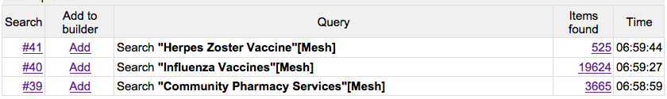

Question #: 37
You are interested in literature related to administration of influenza or shingles (herpes zoster) vaccines by community pharmacy staff members. Which of the following search strategies should be used?

A. #39 AND (#40 OR #41)
B. #39 OR (#40 OR #41)
C. (#39 AND #40 OR #41)
D. #39 OR #40 OR #41
E. #39 AND #40 AND #41
F. (#39 OR #40) AND #41

Question #: 38

You are interested in literature comparing the rates of influenza and shingles (herpes zoster) vaccines by community pharmacy staff members. Which of the following search strategies should be used:

A. #39 AND (#40 OR #41)
B. #39 OR (#40 OR #41)
C. (#39 AND #40 OR #41)
D. #39 OR #40 OR #41
E. #39 AND #40 AND #41
F. (#39 OR #40) AND #41

____________________________________________________________________________

Question #: 39

You have been asked to try to find articles that discuss the effect of smells present in pharmacies on both patients and on pharmacy staff. A faculty member gives you one article that contains a relevant discussion of the effect of aromas. The title and abstract of this article are shown below.

Turkish community pharmacists' self-report of their pharmacies' physical atmosphere.
OBJECTIVE: There is a great recognition that store interiors and exteriors can be designed to create feelings in potential customers which can have an important reinforcing effect on purchase. In this study it is mainly aimed to explore the behaviors of the community pharmacists related to their store's physical environment. Also we aimed to determine whether any difference exist between behaviors of pharmacists serving in high and low socio-economic regions. METHODS: A total of 200 pharmacists that work socio-economically different regions were randomly selected from 1424 pharmacists registered in Ankara Chamber of Pharmacists. A uniform questionnaire was applied to the pharmacists by using a face-to-face interview technique. FINDINGS: There are differences in terms of behavior between the pharmacists serving in high and low socio-economic regions within the context of putting importance to their stores' atmosphere. More pharmacists attach importance to the physical sight of their pharmacy serving in high socio-economic regions (90%) vs. pharmacists in low socio-economic regions (70%). Also pharmacists in high socio-economic regions indicated higher importance level of selection of the decoration equipments (84%) than pharmacists serving in high socio-economic regions (60%). CONCLUSION: Our study suggests that some pharmacists pay more attention to interior atmospheric elements and others do not. There is a difference in terms of attaching importance to some store atmospheric elements (i.e. physical site, decoration equipment, it's color, wall color, etc.) serving in high versus low socio-economic regions in this context.

Which of the following searches would be most likely to locate additional similar articles?

A. Google Scholar search for:
intitle:pharmacy OR intitle:pharmacies environment OR atmosphere smell OR fragrance OR odor OR odour OR smells OR fragrances OR odors OR odours OR aroma OR aromas
B. Google Scholar search for:
intitle:pharmac* environment OR atmosphere smell* OR fragran* OR odor* OR odour* OR aroma*
C. PubMed search for:
intitle:pharmac* environment smell OR fragrance OR odor OR odour OR smells OR frangrances OR odors OR odours OR aroma OR aromas
D. PubMed search for:
pharmac*[ti] AND environment* AND (smell* OR fragran* OR odor* OR odour* OR aroma*)

____________________________________________________________________________

Question #: 41

The intern is so pleased with the information you provided that he asks you for more information. He asks you to research the use of high doses of selenium, doses over 400 mcg/day. You find traditional databases unhelpful and decide to try a Google Scholar search. You use the search strategy --

selenium 400..600 mcg/day supplement OR supplementation

Which of the following Google Scholar hits (a,b,c,all=d, none=e) are likely to be retrieved by your search?

A.
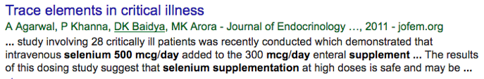
B.
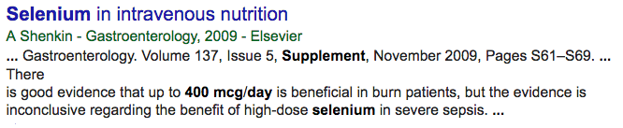
C.
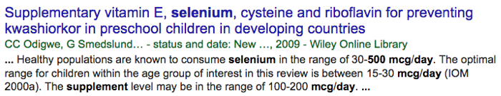
D. All of the above would be retrieved.
E. None of the above would be retrieved.

Question #: 42

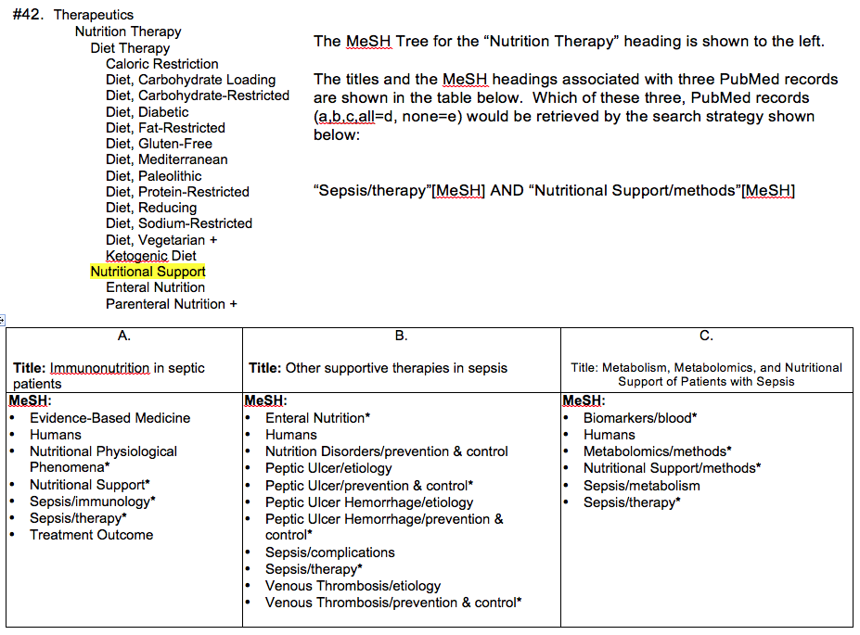

A. Title: Immunonutrition in septic patients
B. Title: Other supportive therapies in sepsis
C. Title: Metabolism, Metabolomics, and Nutritional Support of Patients with Sepsis.
D. All of the above would be retrieved.
E. None of the above would be retrieved.
______________________________________

____________________________________________________________________________
Question #: 45
You and your fellow students are working on a presentation concerning pharmacist involvement in managing pediatric (British spelling paediatric) diabetic patients.

You quickly prepare the following keyword strategy:

(pharmacist*) AND (diabetic* OR diabetes OR antidiabet* OR anti-diabet*) AND (child OR children* OR infan* OR newborn* OR neonat* OR baby OR babies OR adolesc* OR pediat* OR paediat* )

Which of the following would make your search more comprehensive/exhaustive?

A. Insert --
OR childhood OR teen*
–after paediat* and inside the final parenthesis
B. Insert –
OR infancy
–after paediat* and inside the final parenthesis
C. Remove --
OR antidiabet* OR anti-diabet*
D. Add –
AND (treatment)
–to the end of the search.
____________________________________________________________________________

Question #: 46
When you scanned through the results of your initial search for articles about pharmacist involvement in the care of pediatric diabetic patients, you found 12 randomized controlled trials. A friend’s search, shown in the search table below, has retrieved 161 randomized controlled trials, few of which have anything to do with pharmacists.
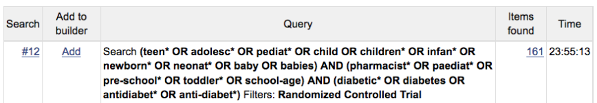

What is the problem with your friend’s search?

A. The "Randomized Controlled Trial" limit should never be used with a keyword search.
B. There is a problem with the number or placement of parentheses.
C. There is a problem with search term placement or grouping.
D. There is a problem with the position or choice of operators (AND, OR, NOT).

